CE213 Class Problem Sheet 5 (Week 7)

(Q1) Determine the logarithm to base 2 of each of the following: 2; 8; 1; 0.5; 0.25; 0.125
(Q2) Suppose the probabilities of tomorrow’s temperature are as follows
P(Warm) = 0.25
P(Cool) = 0.5
P(Freezing) = 0.25
How much information will you receive when you discover tomorrow’s temperature?
[This type of questions can be easily changed to multiple choice questions for progress test]
(Q3) Suppose you are told:
Probability of someone who has a cold suffering from sneezing is 0.9.
Probability of someone who has hay fever suffering from sneezing is 0.8.
Proportion of population with a cold at a given time is 2%.
Proportion of population with hay fever at a given time is 4%.
Proportion of population suffering from sneezing at a given time is 6%.
Assuming that nobody ever has hay fever and a cold at the same time, on the basis of this data determine the probability that a person who is sneezing:
i. has a cold
ii. has hay fever
[Just for fun you may guess before you find the answer which conditional probability is higher.]
(Q4) The following data are used to train a system to determine the best crop to grow in a particular field (given drainage, soil, and PH):
Drainage | Soil | PH | Best Crop
Good | Heavy | Acid | Thistles
Poor | Heavy | Acid | Dandelions
Poor | Light | Acid | Bindweed
Good | Light | Alkaline | Thistles
Good | Heavy | Alkaline | Thistles
Poor | Heavy | Alkaline | Dandelions
Good | Light | Acid | Thistles
Poor | Light | Alkaline | Bindweed

- Calculate the information gains provided by each of the three attributes: Drainage, Soil and PH.
- Construct the decision tree for determining the best crop from the values of these three attributes.
- Convert the decision tree into a production system, i.e., a set of IF_THEN rules.
[ log₂(1/2)=-1, log₂(1/4)=-2, log₂(1/8)=-3 ]
Topics: Logarithm, probability, information, information gain, and decision tree induction
Answers or hints:
Q1: 1, 3, 0, -1, -2, -3
Q2: Information = -sum{i=1 to N}(p_{i}log₂(p_{i})) = -0.25xlog2(0.25)-0.5xlog2(0.5)-0.25xlog2(0.25) = 1.5
Q3: P(cold)=0.02, P(hay fever)=0.04, P(sneezing)=0.06,
P(sneezing | cold)=0.9, P(sneezing | hay fever)=0.8.
Based on the Bayes theorem, we have
P(cold | sneezing)= P(sneezing | cold)*P(cold)/P(sneezing)=0.9*0.02/0.06=0.3
P(hay fever | sneezing)= P(sneezing | hay fever)*P(hay fever)/P(sneezing)=0.8*0.04/0.06=0.53
Q4:
Initial information about Best Crop:
Inf=-(2/8)*log₂(2/8) –( 2/8)*log₂(2/8) –( 4/8)*log₂(4/8))=1.5 bits
Information gain from Drainage:
P(Drainage=good)=P(Drainage=poor)=0.5
P(Bindweed | good)=0, P(Dandelions | good)=0, P(Thistles | good)=4/4
P(Bindweed | poor)=2/4, P(Dandelions | poor)=2/4, P(Thistles | poor)=0
Inf_good=-0-0-(4/4)*log₂(4/4)=0
Inf_poor=-(2/4)*log₂(2/4) -(2/4)*log₂(2/4)-0=1
Average information about best crop given Drainage=0.5×0+0.5×1=0.5
Information gain from Drainage=1.5-0.5=1
Information gain from Soil:
P(Soil=heavy)=P(Soil=light)=0.5
P(Bindweed | heavy)=0, P(Dandelions | heavy)=2/4, P(Thistles | heavy)=2/4
P(Bindweed | light)=2/4, P(Dandelions | light)=0, P(Thistles | light)=2/4
Inf_heavy=-0-(2/4)*log₂(2/4) -(2/4)*log₂(2/4)=1
Inf_light=-(2/4)*log₂(2/4) -0-(2/4)*log₂(2/4)=1
Average information about best crop given Soil=0.5×1+0.5×1=1
Information gain from Soil=1.5-1=0.5
Information gain from PH:
P(PH=acid)=P(PH=Alkaline)=0.5
P(Bindweed | acid)=1/4, P(Dandelions | acid)=1/4, P(Thistles | acid)=2/4
P(Bindweed | alkaline)=1/4, P(Dandelions | alkaline)=1/4, P(Thistles | alkaline)=2/4
Inf_acid=-(1/4)*log₂(1/4) -(1/4)*log₂(1/4) - (2/4)*log₂(2/4))=1.5
Inf_alkaline=-(1/4)*log₂(1/4) - (1/4)*log₂(1/4) - (2/4)*log₂(2/4))=1.5
Average information about best crop given PH=0.5×1.5+0.5×1.5=1.5
Information gain from PH=1.5-1.5=0

Best attribute is Drainage. It is the root node of the decision tree.
For the ‘good’ branch, all samples are from ‘Thistles’ class, leading to a leaf node labelled as ‘Thistles’.
For the ‘poor’ branch, there are 4 samples: 2 from ‘Bindweed’ class and 2 from ‘Dandelions’ class. Calculate information gains from the remaining attributes Soil and HP. Soil is the best attribute now and is used as the node for further extension.
For the ‘heavy’ branch, all samples are from ‘Dandelions’ class, leading to a leaf node labelled as ‘Dandelions’.
For the ‘light’ branch, all samples are from ‘Bindweed’ class, leading to a leaf node labelled as ‘Bindweed’.
Decision tree: Production system:
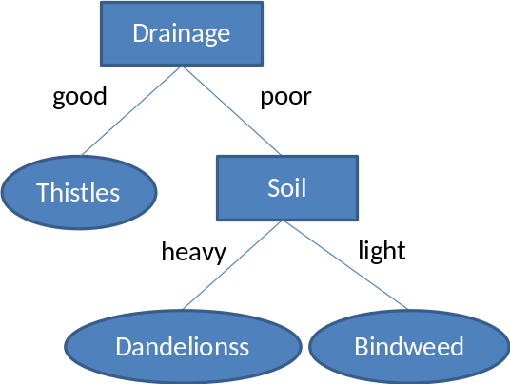
IF Drainage is good
THEN CONCLUDE Best crop is Thistles

IF Drainage is poor AND Soil is heavy
THEN CONCLUDE Best crop is Dandelions

IF Drainage is poor AND Soil is light
THEN CONCLUDE Best crop is Bindweed

